Lab – Locate Your Personal Data

1. Objectives

Find your personal data online and on your computing devices.

1. Background / Scenario

If you search your name online, there is a good chance that you will find some information about yourself in the result. Some of the results may be private information, such as your birthday, that you may want to protect. Some of this information may also be stored on your computing devices.

In this lab, you will use a search engine to search your name to find information about you. You will then use Windows Powershell to search for any personally identifiable information in text files on your Windows PC.

1. Required Resources

* Windows PC with Internet access
  1. Personal Data Online

In step 1, you will search for your name online.

* + 1. Search for your name using your favorite search engine. It may be helpful to surround your name with quotation marks, for example “John Doe”.

What did you find about you?

I saw website with my account that shows basic information such as the school that I go too and personal information such as my birthday, family members.

* + 1. If there are links to your social media profile, navigate to them to view the content as a visitor without logging into any sites.

What information is displayed about you on these sites?

The information that can be accessed into my profile are some pictures and videos, place of work, and my background education.

* + 1. If you are sharing too much, you can change the privacy settings. Here are some ways to get to the security / privacy settings on some of the popular social media sites:

**Facebook**: Click https://scontent-sjc2-1.xx.fbcdn.net/hphotos-xaf1/t39.2365-6/851557_364200877036449_574807949_n.gif, select **Settings**.

**Linked In**: Click your name and select **Settings**.

**Google**: Click your picture or avatar, select **My Accounts**

**Pinterest**: Click **Help Center**, select **My account**

* 1. Personal Data on Your Computing Devices

Besides your online information, some of your personal information may be stored on your computing devices. In this step, you will create a few text files and use Microsoft PowerShell to search for specific information in the text files. The username User1 is used throughout this step in place of your username.

* + 1. Navigate to your Documents directory. Create a directory name **PersonalData**.
    2. Create a few text files using **Notepad** containing the following text and save them in your newly created **PersonalData** directory using the indicated filenames.

|  |  |
| --- | --- |
| Filename | Content |
| **File1.txt** | My Social Security Number is: 111-11-1111 |
| **File2.txt** | My Credit Card Number: 5555-5555-5555-5555  My Social Security Number: 123-45-6789 |
| **File3.txt** | My Credit Card Number:  9999 9999 9999 9999  My ID Number:  987654321 |

* + 1. Click **Start**. Search for **powershell**.

**Note**: If Microsoft PowerShell is not available, you can download it from Microsoft. Please review the installation instructions and system requirement from Microsoft to determine the version to download for your Microsoft operating system.

Vista: <https://www.microsoft.com/en-us/download/details.aspx?id=9864>

Windows 7 and 8: <https://www.microsoft.com/en-us/download/details.aspx?id=48729>

* + 1. Navigate to the **PersonalData** directory by typing the following command at the PowerShell prompt:

PS C:\Windows\System32\WindowsPowerShell\v1.0> **cd c:\Users\User1\Documents\PersonalData**

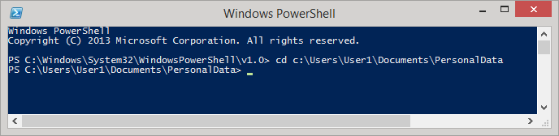

* + 1. Using the scripting commands available in PowerShell, you will search for strings of numbers in these formats: Social Security number XXX XX XXXX and credit card number YYYY YYYY YYYY YYYY.
    2. To search for a string of numbers that may represent a Social Security number, copy and paste the following command into the PowerShell prompt and press **Enter**:

Get-ChildItem -rec -exclude *.exe,*.dll | select-string "[0-9]{3}[-| ][0-9]{2}[-| ][0-9]{4}"

To paste the command, right-click the Powershell title bar and select **Edit > Paste**.

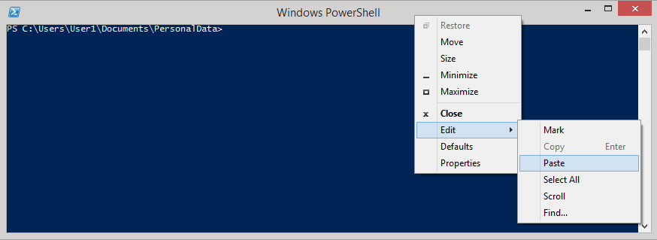

* + 1. The result from the command is displayed below.

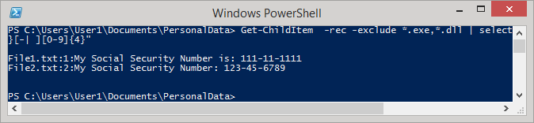

The command allows you to find items that match a defined pattern, such as the pattern for Social Security numbers. The command also excludes files with certain extensions, like .exe and .dll. The results display the text files that contain the defined pattern.

* + 1. To search for credit card numbers with the pattern of 4 groups of 4 numbers (YYYY YYYY YYYY YYYY), copy and paste the following command in the PowerShell prompt:

Get-ChildItem -rec -exclude *.exe,*.dll | select-string "[0-9]{4}[-| ][0-9]{4}[-| ][0-9]{4}[-| ][0-9]{4}"

* + 1. What are the results? Which files contain credit card information?

The results of the code was file2.txt with my credit card number: 5555-5555-5555-5555 and file3.txt with 9999-9999-9999-9999 value.

* + 1. If you are using Linux or Mac OS, the **grep** command can accomplish the same results.

For social security number: **grep '[0-9]\{3\}[-\ ][0-9]\{2\}[-\ ][0-9]\{4\}' \***

For credit card numbers: **grep '[0-9]\{4\}[-\ ][0-9]\{4\}[-\ ][0-9]\{4\}[-\ ][0-9]\{4\}' \***

1. Reflection Question#1:

What other personal data do you store on your devices?

Other data that I input into my devices are personal information that It is important to me such are confidential videos and photos, school related activities.

1. Reflection Question#2:

What are the things that you really find interesting and useful in this activity? Please limit your answers to a minimum of 2 sentences and up to a maximum of 3 sentences.

What amuse me of this activity is that how big the opportunity that this activity brings the fast access of information can be very valuable in terms in programming. Another is how important posting information in social media or in the internet can be dangerous.

1. Reflection Question#3:

Being an Information Technology student, what are the possible ways that this knowledge gained from such activity will make an impact in your individual development process? Use example to clearly illustrate your answers. Please limit your answers to a minimum of 3 sentences and up to a maximum of 5 sentences.

Going through this activity as an upcoming IT professional gives me many opportunity that can be beneficial in the real world. Understanding the importance of information privacy is one of many aspects that IT professional take significances. Another is how to handle those information such as managing data and retrieving data.